### 

**Product Dissection for Zomato**

### 

### **Company Overview:**

Launched in 2010, Zomato's technology platform connects customers, restaurant partners and delivery partners, serving their multiple needs. Customers use Zomato platform to search and discover restaurants, read and write customer generated reviews and view, order food delivery, book a table and make payments while dining-out at restaurants. On the other hand, Zomato provides restaurant partners with industry-specific marketing tools which enable them to engage and acquire customers to grow their business while also providing a reliable and efficient last-mile delivery service. Zomato also operates a one-stop procurement solution, which supplies high quality ingredients and kitchen products to restaurant partners.

### **Product Dissection and Real-World Problems Solved by Zomato:**

Zomato, the popular food delivery app, addresses numerous real-world problems with its comprehensive platform. It revolutionizes the dining experience by offering unparalleled convenience, allowing users to effortlessly browse a wide range of restaurants, view menus and place orders from the comfort of their homes. By providing access to an extensive array of cuisines and dishes, Zomato tackles the issue of limited options present in traditional dining scenarios, especially in areas with fewer restaurant choices.

Moreover, its integration of user-generated reviews and ratings empowers users to make informed decisions about where to order from, mitigating the uncertainty associated with trying new eateries. The app's customization options cater to individual preferences and dietary restrictions, solving the problem of limited flexibility in ordering food.

Additionally, Zomato's frequent discounts and promotions make dining out or ordering in more affordable, while its real-time delivery tracking feature provides users with peace of mind regarding the status of their orders. Furthermore, Zomato serves as a platform for culinary discovery and exploration, enabling users to uncover new restaurants and cuisines based on their preferences and location.

Overall, Zomato streamlines the food ordering and dining experience, offering convenience, variety, transparency and affordability, thereby solving several real-world problems associated with traditional food delivery and dining services.

### **Case Study: Real-World Problems and Zomato's Innovative Solutions**

Zomato, a popular food delivery app, solves several real-world problems related to food delivery, dining, and discovering new restaurants. Let's dissect the product and explore some of the problems it addresses:

**Problem 1: Food Ordering Experience**

**Real-World Challenge:** Traditional methods of ordering food often lack the convenience and efficiency desired by modern consumers. Phone calls can be time-consuming and prone to errors, leading to a disconnect between customers and the food delivery process.

**Zomato's Solution:**

Zomato revolutionizes the food ordering experience by providing a convenient and user-friendly platform for browsing menus, placing orders and tracking deliveries in real-time. By streamlining the process through a mobile app, Zomato bridges the gap between customers and restaurants, enhancing communication and reducing the disconnect often experienced in traditional food ordering methods.

**Problem 2: Limited Restaurant Options and Information**

**Real-World Challenge:** Customers often face the dilemma of choosing from a limited selection of restaurants in their area, with little information available about each option's menu, pricing and reviews.

**Zomato's Solution:**

Zomato addresses this challenge by offering a comprehensive database of restaurants with detailed menus, pricing information, user reviews and ratings. This information empowers customers to make informed decisions about where to order from expanding their choices and ensuring a satisfying dining experience.

**Problem 3: Uncertainty in Delivery Times and Status**

**Real-World Challenge**: Traditional food delivery services often lack transparency regarding delivery times, leading to frustration and uncertainty among customers.

**Zomato's Solution:**

Zomato provides customers with real-time tracking of their orders, allowing them to monitor the status of their delivery and receive accurate estimated arrival times. By enhancing transparency and communication throughout the delivery process, Zomato alleviates the uncertainty often associated with food delivery, improving the overall customer experience.

**Problem 4: Lack of Personalization and Customization Options**

**Real-World Challenge:** Customers with specific dietary preferences, allergies, or taste preferences often struggle to find food options that cater to their needs through traditional ordering methods.

**Zomato's Solution:**

Zomato offers customers the ability to customize their orders, providing options to accommodate dietary restrictions, preferences, and special instructions. This level of personalization ensures that customers receive food tailored to their individual needs, addressing the problem of limited customization options in traditional food ordering services.

**Conclusion:**

Zomato's innovative approach to food delivery tackles several real-world challenges faced by customers, including convenience, choice, transparency and personalization. By leveraging technology to streamline the ordering process and enhance communication between customers and restaurants, Zomato has significantly improved the food ordering experience, cementing its position as a leader in the food delivery industry.

### **Top Features of Zomato:**

1. **Restaurant Discovery:** Zomato provides users with a vast database of restaurants, allowing them to discover new dining options based on cuisine, location, ratings, and reviews.
2. **Menu Exploration**: Users can explore detailed menus of restaurants listed on Zomato, including pricing, dish descriptions and images, enabling informed decision-making when ordering food.
3. **Order Placement:** Zomato allows users to place orders directly through the app, streamlining the food ordering process and eliminating the need for phone calls or manual order placement.
4. **Real-Time Order Tracking:** Users can track the status of their food orders in real-time from preparation to delivery, providing transparency and peace of mind throughout the process.
5. **User Reviews and Ratings:** Zomato integrates user-generated reviews and ratings for restaurants, helping users make informed decisions about where to dine or order food from based on the experiences of others.
6. **Discounts and Deals:** Zomato frequently offers discounts, deals and promotions on food orders, making dining out or ordering in more affordable for users and providing added value to the service.

### **Schema Description:**

The schema for Zomato involves multiple entities that represent different aspects of the platform. These entities include Users, Orders, Restaurants, Payment, Review, Delivery Partner and more. Each entity has specific attributes that describe its properties and relationships with other entities.

**User Entity:**

Users are at the core of Zomato. The user entity contains information about each user:

* **User_ID (Primary Key)**: A unique identifier for each user.
* **Full_Name**: The user's full name as displayed on their profile.
* **Email**: The user's email address for account-related communication.
* **Phone_Number:** This is the phone number of the user.
* **Joining_Date**: The date when the user joined Zomato.
* **Membership:** Does the user have a membership or not.
* **Rating:** Rating of user.

**Restaurants Entity:**

Restaurants on Zomato are places where users can order food. Each restaurant listing provides information about that particular establishment:

* **RestaurantID (Primary Key):** A unique identifier for each restaurant.
* **Name**: Name of the restaurant
* **Address**: Address of the restaurant.
* **Phone_Number:** Contact number of restaurant.

**Partners Entity:**

Delivery partners are the individuals responsible for delivering orders from restaurants to users:

* **PartnerID (Primary Key)**: A unique identifier for each delivery partner.
* **Partner_Name:** Name of the Delivery partner.
* **Phone_Number**: contact number of delivery partner.
* **Email:** Email ID of the delivery partner.
* **Partner_Rating**: Rating of the delivery partner (1 to 5)
* **Delivery_Area:** The geographic area or region covered by the delivery partner for order deliveries.
* **Licence_no:** Driving licence number of the delivery partner.

**Order Entity:**

Order placed by users:

* **OrderID (Primary Key):** A unique identifier for each Order.
* **UserID (Foreign Key referencing User Entity):** User who made the order.
* **RestaurantID (Foreign Key referencing Restaurant Entity):** Identifies the restaurant from which the order was placed.
* **Order_Date:** Date and time at which the order was placed
* **Order_Status:** Status of the Order (Delivered or Cancelled)
* **PartnerID (Foreign Key referencing Partner Entity):** Identifies the delivery partner responsible for delivering the order.
* **Delivery_Date :** The date and time when the order was delivered.
* **AddressID (Foreign Key referencing Address Entity):** Identifies the address from which the order should be delivered.
* **Total_amount:** The total amount of the order, including taxes and delivery charges.
* **Coupon_code:** This attribute stores any coupon codes applied to the order, providing discounts or special offers
* **Discount_amount:** The amount after the discount by using a coupon.
* **ReviewID (Foreign key referencing Review Entity):** Links the order to any review left by the user for the restaurant after the order is completed**.**

**Payment Entity:**

Payments represent the financial transactions associated with orders on Zomato:

* **PaymentID (Primary Key)**: A unique identifier for each payment done.
* **OrderID (Foreign Key referencing Order Entity)**: The user who is being followed.
* **Payment_Mode**: Mode of Payment chosen by the user.
* **Payment_Status:** Status of the payment such as pending, processed or completed.
* **Payment_Date**: The date and time when the payment was made.
* **Amount:** The amount of payment made.

**Menu Entity:**

Menu available at the restaurant:

* **ItemID (Primary Key):** A unique identifier for each menu item.
* **RestaurantID (Foreign Key):**  Links the menu item to the restaurant it belongs to.
* **Item_Name:** The name of the menu item.
* **Description:** A brief description of the menu item, including ingredients or special features.
* **Price:** The price of the menu item.
* **Category:** The category or type of the menu item, such as appetizer, main course, dessert, etc.
* **Availability:** Indicates whether the menu item is currently available for order.

**Address Entity:**

Address of the users from which order is made:

* **AddressID (Primary Key):** A unique identifier for each address.
* **UserID (Foreign Key referencing user entity):** Links the address to the user who placed the order.
* **Address:** The complete address, including street address, city, state, postal code, and country.

**Review Entity:**

Reviews represent the feedback provided by users about their dining experience at a restaurant:

* **ReviewID (Primary Key)**: A unique identifier for each review made by the user.
* **UserID (Foreign Key referencing Order Entity)**: user who made the review.
* **RestaurantID (Foreign Key referencing Restaurant Entity)**: identifies the restaurant being reviewed.
* **Rating:** Rating given by the user to restaurants a scale of (1 to 5)
* **Comments:** Any additional comments or feedback provided by the user about their experience.
* **Review_Date:** The Date at which Review is being made.

### **Relationships are:**

Here are the relationships between the tables in the Zomato database design:

1. **Users — Orders:** A user can place multiple orders and each order is placed by a single user. This is a one-to-many relationship.
2. **Restaurants — Orders:** A restaurant can have multiple orders placed for it and each order is placed at a single restaurant. This is a one-to-many relationship.
3. **Orders — Payment:** Each order will have a single payment associated with it, and each payment is for a single order. This is a one-to-one relationship.
4. **Orders — Partners:** Each order will have a single delivery partner associated with it, and each delivery partner is assigned to multiple orders. This is a one-to-many relationship.
5. **Users — Rating**: A user can rate multiple restaurants and each restaurant can be rated by multiple users. This is a many-to-many relationship.
6. **Restaurants — Rating:** A restaurant can be rated multiple times by different users and each rating belongs to a single restaurant. This is a one-to-many relationship.
7. **Users — Address:** A user can have multiple delivery addresses and each address belongs to a single user. This is a one-to-many relationship.
8. **Restaurants — Menu:** A restaurant can have multiple menu items and each menu item belongs to a single restaurant. This is a one-to-many relationship.

### **ER Diagram:**

Let's construct an ER diagram that vividly portrays the relationships and attributes of the entities within the Zomato schema. This ER diagram will serve as a visual representation, shedding light on the pivotal components of Zomato's data model. By employing this diagram, you'll gain a clearer grasp of the intricate interactions and connections that define the platform's dynamics.

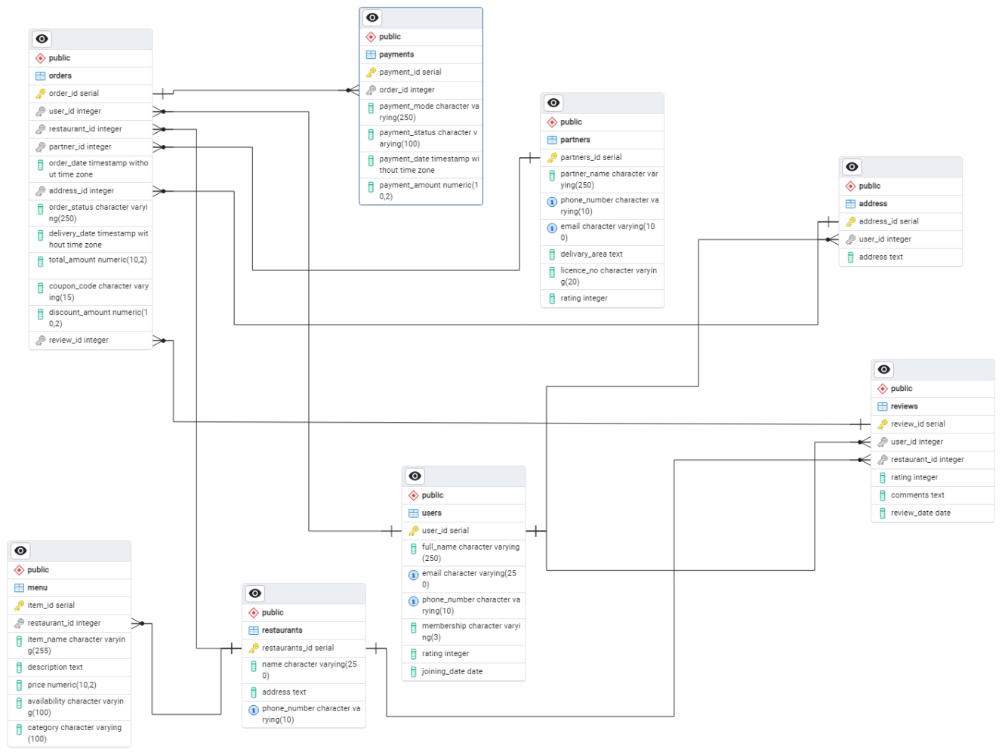

### **Conclusion**

In this case study, we explored Zomato's schema and operational framework, revealing its role as a transformative force in food delivery. Zomato seamlessly connects users, restaurants and delivery partners through its platform. By dissecting its schema, we gained insights into how Zomato efficiently manages food ordering and delivery complexities.

Zomato addresses real-world challenges like limited restaurant options and uncertain delivery times by offering features for restaurant discovery, menu exploration and real-time order tracking. The schema analysis highlights how data flows within the platform to facilitate smooth interactions, showcasing Zomato's commitment to user satisfaction and operational excellence.